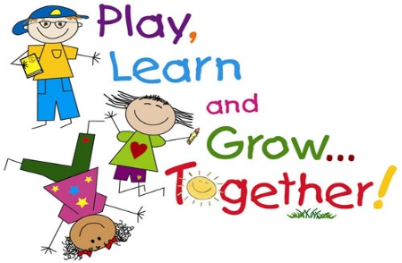Powers County Preschool Inclusive Program

May 5, 2015

To the Parents/Guardians of ___________________________________,

Thank you for your application to our preschool program. We are pleased to inform you that your child was chosen for participation in the Powers County Preschool Inclusive Program for the upcoming year. In August you can expect a letter from your child’s teacher with information about dates for Open House and Preschool Orientation as well as school medical forms and school supply lists.
We would like to thank you for your interest and support of this program and look forward to working with your child next fall.

Sincerely,

Principal Preschool Teachers

